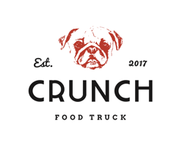
Spicy hot dog
Jalapenos, cheddar cheese, chili sauce.
Crunchy bacon hot dog
Bacon, cheddar cheese, crunchy onions, ketchup.
Crunchy nachos hot dog
Nachos, cheddar cheese, guacamole, jalapenos,, nachos sauce.
Mexican hot dog
Guacamole, yellow pepper, tomatoes, onions, honey mustard sauce.
Kids hot dog
Ketchup/mayonnaise + surprise.
XL Nachos

